**international communications**

**30-day media report – Research article**

**Original paper:** Iridium oxide and cobalt hydroxide microfluidic-based potentiometric pH sensor

**Journal:** Microchimica Acta

**Authors:** Weiyu Xiao & Qiuchen Dong

**Date Published:** 2 November 2023

**DOI:** <https://link.springer.com/article/10.1007/s00604-023-06035-z>

**Title of press release:** The little things matter: Chemists develop new sensor for microvolume pH detection

**Date Published:** 3 November 2023

**URL:** <https://www.xjtlu.edu.cn/en/news/2023/11/little-things-matter>

**Total number of unique readers of the media outlets that picked up the article per month:**

10,292,485

**Number of media outlets that picked up the media release (not including Chinese outlets):**

18

**Languages the article has been translated into (not including Chinese):**

French, German, Spanish

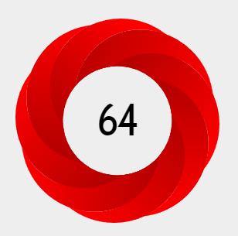**Altmetric score:**

**In the top 3% of all research outputs scored by Altmetric.**

The Altmetric Attention Score for a research output provides an indicator of the amount of attention that it has received. The score is derived from an automated algorithm, and represents a weighted count of the amount of attention we've picked up for a research output.

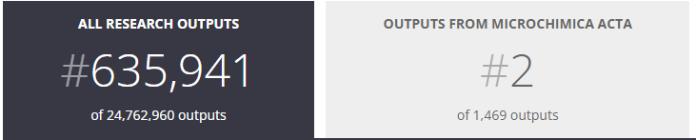

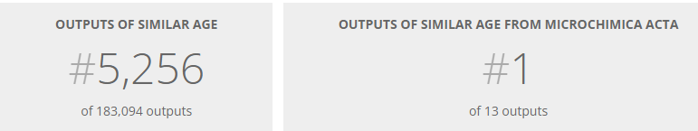

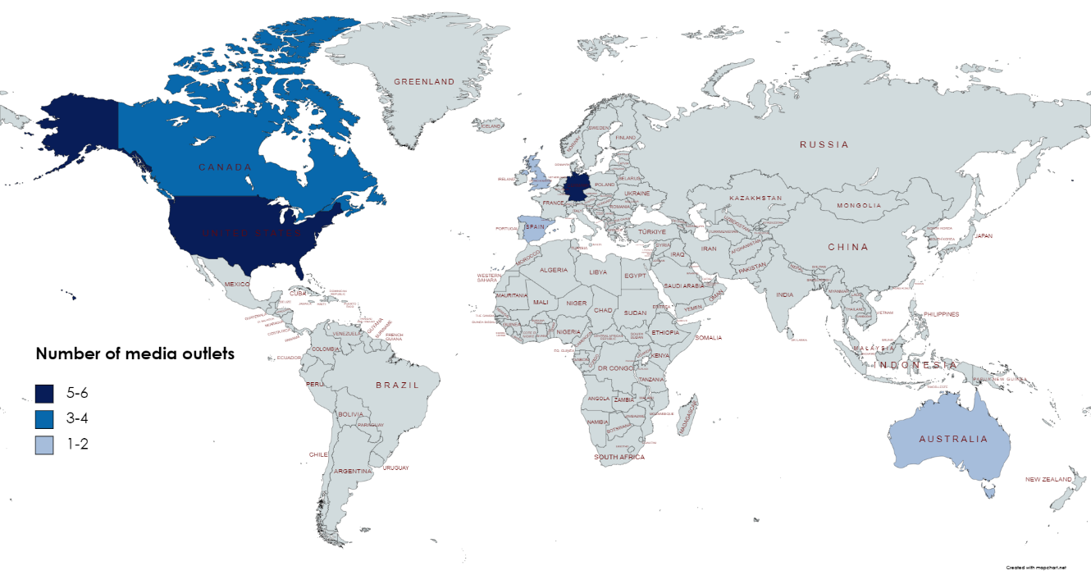**Number of media outlets that picked up the media release by country (not including China)**

Thanks for your support and we look forward to working with you again!

The International Communications Team